AI Health care Chat Bot using Python

Submitted by

Shaik Mohammed Anas

Kotakonda Uday Kiran

Lakkam Sai Sandeep

Under the Guidance of

Dr. P Sundarraman

Assistant Professor



Department of Electrical, Electronics and Communication Engineering

GITAM School of Technology

GITAM

(DEEMED TO BE UNIVERSITY)

(Estd. u/s 3 of the UGC act 1956)

NH 207, Nagadenehalli, Doddaballapur taluk, Bengaluru-561203 Karnataka, INDIA.



Department of Electrical, Electronics and Communication Engineering

GITAM School of Technology

DECLARATION

I/We declare that the project work contained in this report is original and it has been done by me under the guidance of my project guide.

Date:

Registration No. Student Name Signature

BU21EECE0100102 S. Md Anas

BU21EECE0100415 K. Uday Kiran

BU21EECE0100434 L. Sai Sandeep

Department of Electrical, Electronics and Communication Engineering

GITAM School of Technology, Bengaluru-561203



CERTIFICATE

This is to certify that Shaik Md Anas bearing BU21EECE0100102, K. Uday Kiran bearing BU21EECE0100415, L. Sai Sandeep bearing BU21EECE0100434 has satisfactorily completed Mini Project Entitled in partial fulfillment of the requirements as prescribed by University for VIIth semester, Bachelor of Technology in “Electrical, Electronics and Communication Engineering” and submitted this report during the academic year 2024-2025.

[Signature of the Guide] [Signature of HOD]

Table of contents

Chapter 1: Introduction 1

Chapter 2 : Literature Review 2

Chapter 4 : Methodology 4

Chapter 5:Results 6

Chapter 6: Conclusion 7

Chapter 7 : Future Work 8

Here write Suggestions for further research or development Potential improvements or extensions 8

References 9

# 

# Chapter 1: Introduction

## 1.1 Overview of the problem statement

A Python-Powered AI Healthcare Chatbot created to serve users with the following responsibilities:

Symptom Checking: Diagnosing what's wrong and telling you to go see the doc or not

Health Information: General information on diseases, drugs and medication; treatment.

Mental Health Support: Basic counselling and referring to a mental health expert.

Data Collection: To collect health-related data for measurement and sharing with providers

Custom Advice: Providing personal health advice based on user data.

Home Remedies: Advising Basic Home Remedies without Tablets.

Key Emergency Guidance: Instant steps for complete emergencies.

These are implemented with the Python using such libraries as NLP, machine learning and web frameworks.

## 1.2 Objectives and goals

Objectives:

To develop a Python-Powered AI Healthcare Chatbot

Goals:

Main Goals

* Home Remedies
* Ayurvedic
* Personalized Health Advice
* Mental Health Support
* Reduce Healthcare Costs

Additional Goals

* Enhance Access to Healthcare
* Information Delivery

# Chapter 2: Literature Review

Key Publications

* AI Based Healthcare Chatbot System by Using Natural Language Processing.
* A Healthcare Chatbot System Using Python And NLP
* Contextual Chatbot for Healthcare Purposes (using Deep Learning)
* Chatbot for Health Care and Oncology Applications Using Artificial Intelligence and Machine Learning: Systematic Review

Google scholar Publications:

<https://ieeexplore.ieee.org/abstract/document/9456304>

https://www.pnrjournal.com/index.php/home/article/view/10131

Github Publications:

https://github.com/manyasrinivas2021/ARTIFICIAL-INTELLIGENCE-HEALTHCARE-CHATBOT--SYSTEM-USING-PYTHON

https://github.com/mmubarak0/AI-Healthcare-chatbot

# Chapter 3: Strategic Analysis and Problem Definition

## 3.1 SWOT Analysis

#### **Strengths**

#### 24/7 Availability: The chatbot is available around the clock, providing instant responses to healthcare queries, improving accessibility for patients.

#### Scalability**:** The AI model can handle multiple users simultaneously, making it scalable for large healthcare systems.

#### Cost**-**EffectiveSolution**:** Reduces the burden on healthcare professionals by automating basic consultations, which can lower operational costs.

#### Personalization**:** The system can offer personalized health advice based on user inputs, potentially improving user satisfaction.

#### **Weaknesses**

#### Limited Understanding of Complex Medical Issues: The chatbot may struggle with complex or ambiguous medical queries, requiring user redirection to healthcare professionals.

#### Data Privacy Concerns: Handling sensitive healthcare data requires stringent security measures, which could pose challenges.

#### Reliability on External Databases: The chatbot's accuracy depends on the quality of external medical databases and APIs, which might not always be updated in real time.

#### Language Barriers: Initially, the chatbot may be limited to a single language, reducing accessibility for non-native speakers.

#### **Opportunities**

### Growing Demand for Telemedicine: With the increasing popularity of telemedicine, an AI Health Care Chatbot can complement virtual consultations by answering common questions.

### Integration with Wearable Devices: Linking the chatbot with wearable health devices can offer real-time monitoring and personalized health advice.

### Partnership with Healthcare Providers: Collaborating with hospitals or clinics can enhance the chatbot's credibility and expand its use in formal healthcare settings.

### AI and Machine Learning Advancements: Continuous improvements in AI technologies provide opportunities to enhance the chatbot’s diagnostic accuracy and user experience.

### 3. Project Plan - GANTT Chart

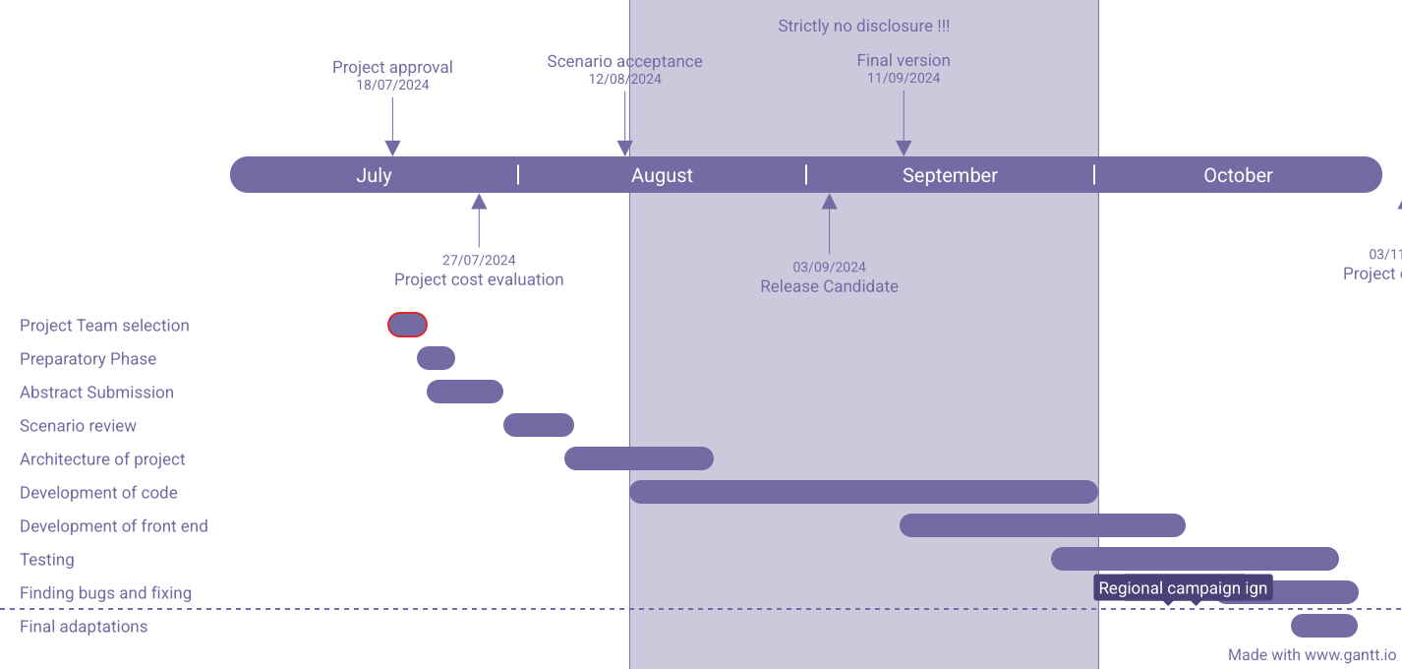

##### 

##### 3.3 Refinement of problem statement

Healthcare challenges have intensified due to growing patient demand and limited availability of medical professionals, leading to long waiting times, overburdened healthcare systems, and delayed access to critical care. Traditional methods of handling patient queries and providing initial consultations are inefficient, often resulting in an overuse of healthcare resources for minor concerns, while serious cases may not receive timely attention. This project aims to develop an AI-powered Health Care Chatbot that provides instant responses to common medical queries, offers guidance based on symptoms, and helps users determine the appropriate level of care. By leveraging modern technologies such as AI, Natural Language Processing (NLP), and machine learning, the system will streamline healthcare access, reduce the burden on medical professionals, and enhance patient experience by offering reliable, 24/7 health information. The chatbot will contribute to more efficient healthcare management, reducing unnecessary doctor visits, improving patient satisfaction, and promoting more effective use of healthcare resources.

# Chapter 4: Methodology

### **Methodology**

* **Requirements Gathering**: Conduct interviews with healthcare professionals and potential users (patients) to identify the most common medical queries and needs. This will help in defining the key functionalities of the chatbot.
* **Design Phase**:
  + Develop the chatbot’s ability to understand and process human language using NLP libraries like NLTK and TensorFlow. The chatbot should interpret user inputs and extract relevant medical terms.
  + Design the system architecture consisting of the front-end (user interface) and back-end (logic, databases, APIs).
* **Development Phase**:
  + Use HTML, CSS, and JavaScript to develop a responsive web interface where users can interact with the chatbot.
  + Use Python with Flask to build the server-side logic that processes user queries and interacts with the medical database.
  + Integrate the chatbot with external APIs like MedlinePlus for accessing real-time medical data.
* **Testing Phase**:
  + Training the AI Model:  
    Use medical datasets to train the chatbot on common symptoms, conditions, and treatments. Ensure the model can differentiate between critical and non-critical conditions.
  + Unit Testing: Test individual components like the response system, user interaction, and database connectivity to ensure functionality.
  + **User Acceptance Testing (UAT)**: Gather feedback from real users to refine the system.

2. Techniques:

### **Frontend Technologies**

* **HTML/CSS**: Fundamental technologies for creating the structure and styling of web pages.
* **JavaScript Frameworks**:
  + **React**: A popular library for building interactive user interfaces.
  + **Angular**: A platform for building web applications with a focus on a structured approach.
  + **Vue.js**: A progressive framework for building user interfaces, known for its simplicity and flexibility.

### 2. **Backend Technologies**

### Programming Language: Python

### Libraries: TensorFlow (for machine learning), NLTK (for natural language processing), Flask (for web framework)

### Database: MySQL (for user data storage)

### APIs: MedlinePlus API for accessing medical information

### 3. **Database Technologies**

* **MySQL:**  
  A widely used open-source relational database management system. MySQL is suitable for structured data, such as user profiles, medical query logs, and chatbot interaction histories. It ensures data integrity and supports complex queries, making it ideal for storing user inputs and chatbot responses in a structured format.
* **MongoDB:**  
  A flexible, document-based NoSQL database that stores data in a JSON-like format. MongoDB is ideal for storing unstructured or semi-structured data, such as medical articles, chatbot response templates, or patient feedback. It scales easily, making it a good fit for applications where the data schema may evolve over time.

Chapter 6 Results

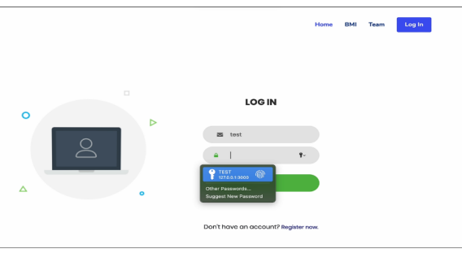

# Chapter 7: Conclusion

### In summary, the AI Health Care Chatbot offers an accessible and efficient way for patients to receive healthcare guidance. The integration of AI and NLP allows the system to address basic medical inquiries, easing the load on healthcare providers. This tool can improve patient care by delivering immediate responses, while also reducing unnecessary hospital visits.

### **Chapter 8: Future plans**

* **Integration with Wearable Devices:**  
  Allow the chatbot to receive data from wearable health devices to provide more personalized advice.
* **Advanced NLP Features:**  
  Improve the chatbot’s ability to understand complex medical queries and provide more accurate responses.
* **Multilingual Support:**  
  Implement support for multiple languages to cater to a broader user base.
* **Mobile Application:**  
  Develop a mobile app version of the chatbot for greater accessibility.